DATA CLEANING
The Data Cleaning Log below documents every step taken to improve the quality of the dataset, including the issue identified, the action taken, the rationale behind each decision and the final status of each step. All 17 cleaning steps are recorded across six sections covering column removal, column renaming, format corrections, text standardisation, column splitting, and missing value handling.
Data Cleaning Log: Data Cleaning Log

DATA COMPARISON SUMMARY
The following tables document the measurable improvements made to the dataset through the cleaning process. The raw dataset contained 80 columns, significant missing values, formatting inconsistencies, and structural issues. After cleaning, the dataset was reduced to 33 focused columns with standardised values, converted timestamps and clearly labelled missing data.
Overall Dataset Structure
Property | Raw Dataset | Cleaned Dataset | Change
Total Columns | 80 | 33 | 47 columns removed
Total Rows | 7,543 | 7,543 | No changes
Duplicate Rows | 0 | 0 | No changes
Completely Empty Columns | 38 | 0 | 38 removed
Zero-variance Columns | 5 | 0 | 5 removed
Duplicate Columns | 6 | 0 | 6 removed
Unreadable Timestamp Columns | 3 | 0 | 3 converted
Column names spelling errors | 2 | 0 | 2 fixed

Overall Data Quality Score
Quality Dimension | Before Cleaning | After Cleaning
Completeness | Poor - 38 columns entirely empty | Good - all remaining columns contain data
Consistency | Poor - mixed formats across key columns | Good - standardised across Country, Source, Outcomes
Accuracy | Moderate - timestamps unreadable, names misspelled | Good - timestamps converted, names corrected
Usability | Poor - 80 columns with much noise | Good - 33 focused, meaningful columns
Structure | Moderate - combined columns, duplicates | Good - splitted where possible, duplicates removed

Full comparison tables including missing value changes, data consistency changes and column-level changes are available in the attached spreadsheet: Data Comparison Summary.

CLEANED DATASET
The cleaned dataset below represents the final version of the DePaul University student application data following all documented cleaning actions. It has been reduced from 80 columns to 33 columns, with standardised values, corrected formats and clearly labelled missing data. This dataset forms the reliable foundation for all further analysis in the coming weeks.
Cleaned Dataset: DePaul_Dataset.

DATA VISUALIZATION
The full data tables used for the visualizations are in this file: Data Cleaning Visualizations. The images below show different comparisons before the dataset was cleaned and after the dataset was cleaned, every change was recorded.
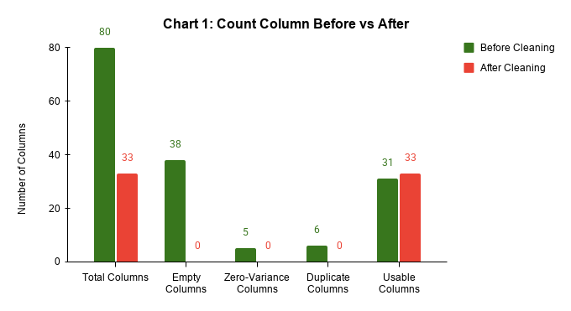
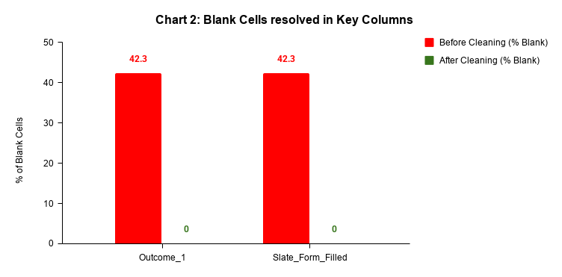
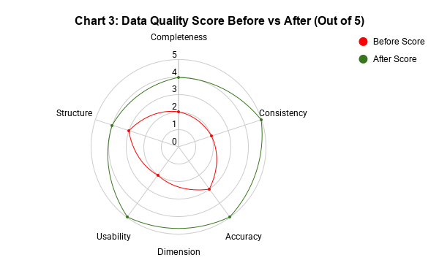
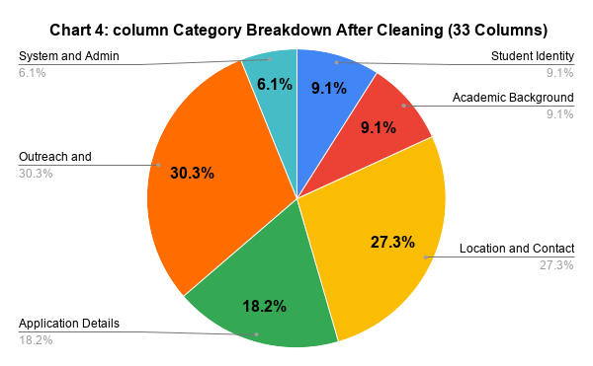
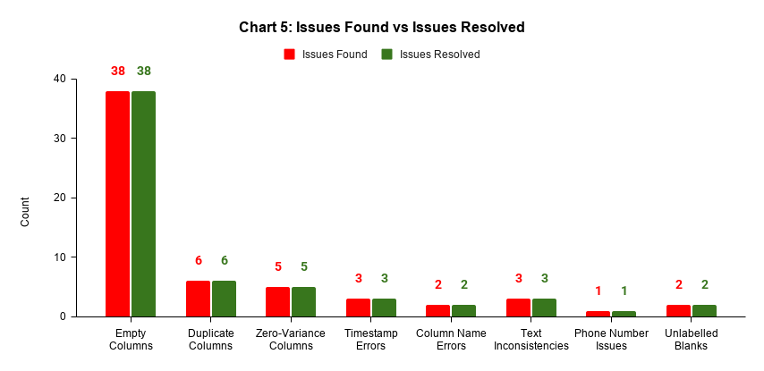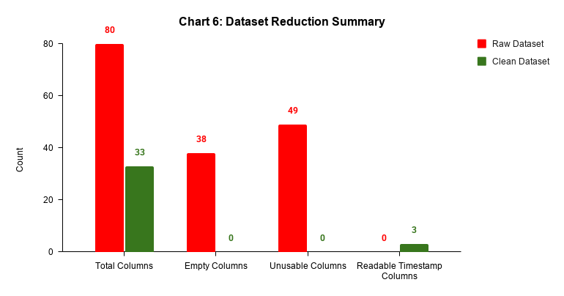

SUMMARY REPORT
Overview
The raw DePaul University student application dataset was transformed from an 80-column, heavily incomplete file into a clean, analysis-ready dataset of 33 columns. A total of 17 documented cleaning steps were executed across six categories: column removal, renaming, format correction, text standardisation, column splitting, and missing value handling, all driven by findings from the Week 1 Data Quality Report.
Impact on Data Quality
Metric | Before | After
Total Columns | 80 | 33
Empty Columns | 38 | 0
Unusable Columns | 49 | 0
Unreadable Timestamp Columns | 3 | 0
Column Name Spelling Errors | 2 | 0
Blank Cells in Outcome_1 | 42.3% | 0%
Blank Cells in Slate_Form_Filled | 42.3% | 0%
Overall Data Quality Score | 2.4/5 | 4.6/5
Additional improvements include standardised country names across 95+ values, unified Application_Source formatting, corrupted phone numbers flagged in a new Phone_Flag column, and Intake successfully split into Program and Intake_Term columns.
Limitations
Three issues could not be fully resolved. The College column was retained as its inconsistent structure made automated splitting unreliable across 7,543 rows and is flagged for future cleaning. Remark and Remark_2 remain 91.1% and 98.9% empty but were retained for their qualitative value. Phone number formats could not be fully standardised, corrupted entries are flagged and unrecoverable.
Implications for Further Analysis
The cleaned dataset now enables reliable trend analysis using properly formatted date columns, accurate country-level grouping, cleaner outreach effectiveness measurement through labelled Outcome_1 values and program-level filtering through the newly split Program and Intake_Term columns. The College column should be treated with caution in any analysis involving students' previous institutions until it is fully cleaned.

